





No: HKM/GDC/ED/Plantation drive
Dated: 24-o3-2025

Report on Plantation drive organized at HKM GDC Eidgah, Srinagar.
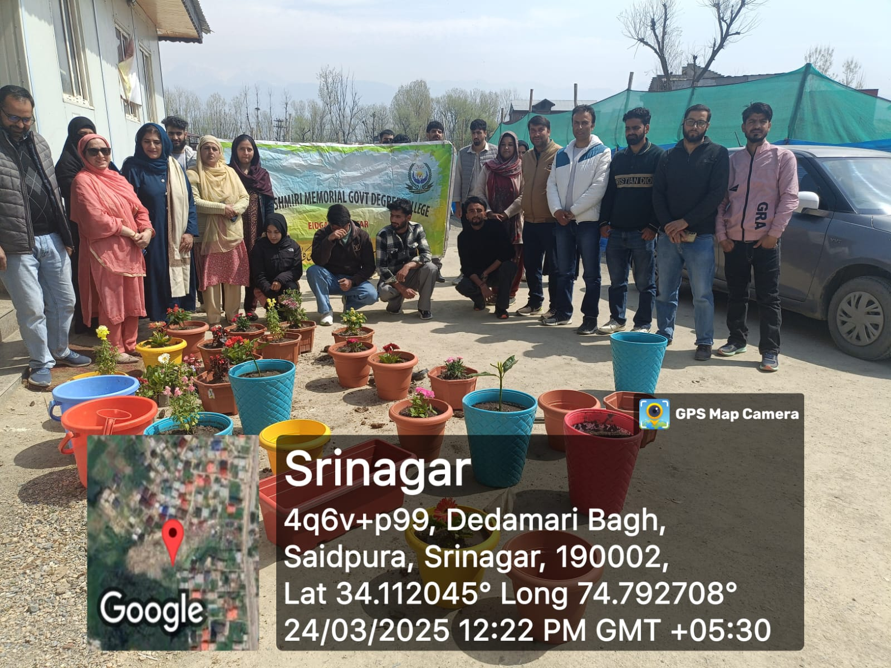
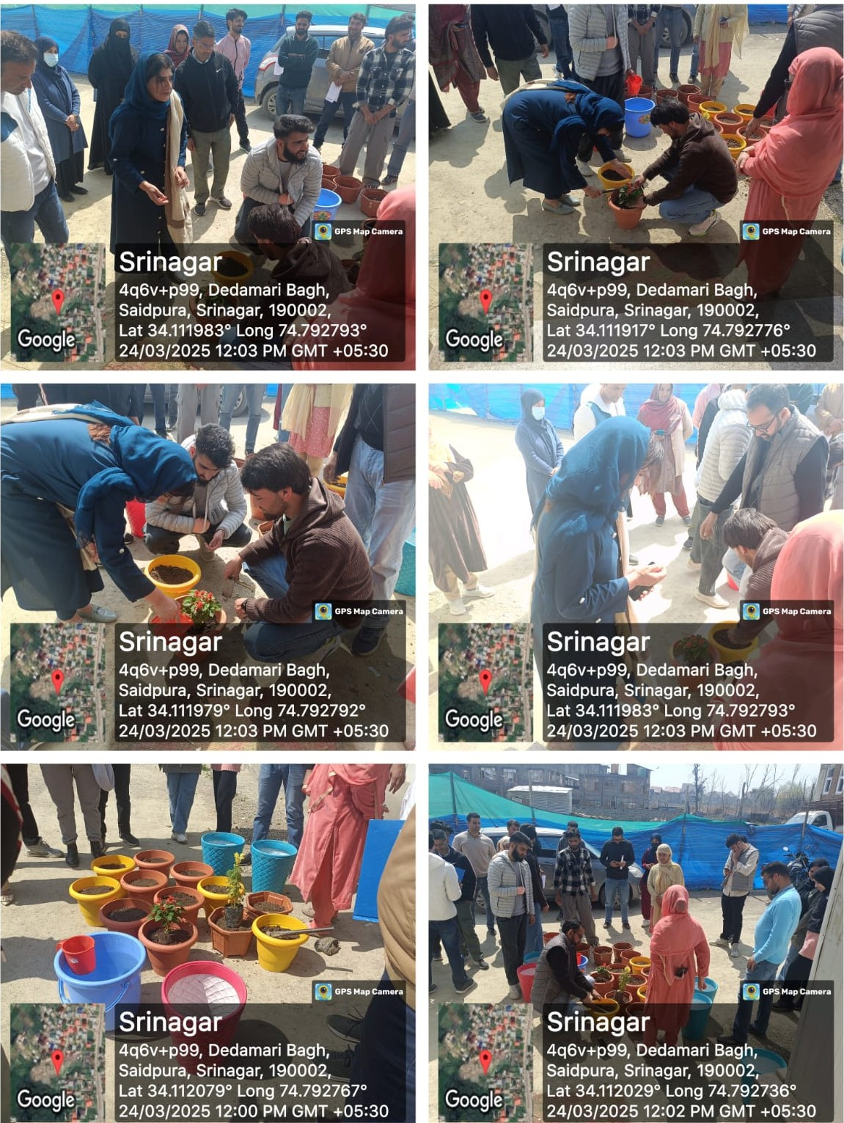
In an effort to promote environmental sustainability and create awareness about the importance of afforestation, The NSS units(I&II) in collaboration with Women Development Cell (WDC), Landscape & beautification committee and GCCASH of HKM GDC Eidgah organized a Plantation drive under the Theme Ek Ped Maa Ki Naam and under the banner of Beti Bachao, Beti Padhao within the college campus on 24/03/2025. The event aimed to combine environmental consciousness with the recognition of women’s invaluable role in nurturing and shaping future generations. The programme was conducted under the Patronage and able guidance of Worthy Principal of the college, Prof.(Dr) Nighat Nasreen. The drive witnessed enthusiastic participation from NSS volunteers, faculty members, and students, all contributing towards making the campus greener.
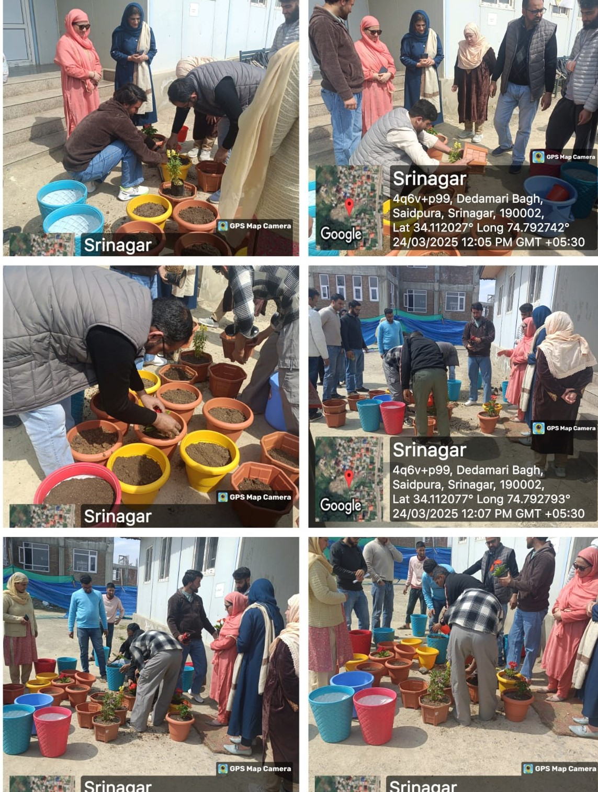
The event was inaugurated by Worthy Principal Madam who emphasized the importance of planting trees in maintaining ecological balance which is currently the need of hour to save our environment and applauded the creative approach of linking the plantation drive with the Beti Bachao Beti Padhao campaign. Further she stressed that it is responsibility of every individual to plant as many saplings as possible so as to prevent the environment from degradation as plantation is vital to maintain the ecological balance. This was followed by Dr. Nusrat Shafi (Convener GCCASH) who highlighted the objectives of the Beti Bachao Beti Padhao initiative and need to recognize and empower women. She also spoke about the critical role plants play in preserving biodiversity and mitigating climate change. After these thought provoking words, Worthy Principal Madam initiated the drive by planting a sapling of Dahlia. Later other faculty members of the college also planted a good number of saplings of ornamental plants. NSS volunteers participated in the drive with great Zest and Zeal and planted many saplings of Ornamental Plants dedicating each sapling to their mothers. Overall 50 saplings of various ornamental plants such as Marigold, lavender, dahlia, lily, Petunias, tulips, Daffodils, zinnias, hibiscus etc and other plant saplings were planted. The drive was a huge success empowering students with substantial knowledge of environment and also served as a reminder of the profound influence of mothers in shaping a better future and encouraged participants to work towards the empowerment of women in all spheres. The drive ended with a Vote of Thanks by Dr Jabeena Khazir (NSS PO Unit II). Refreshment was served to all the Participants.
