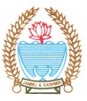
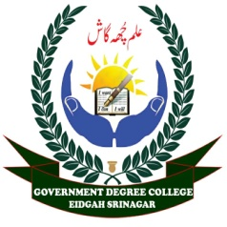
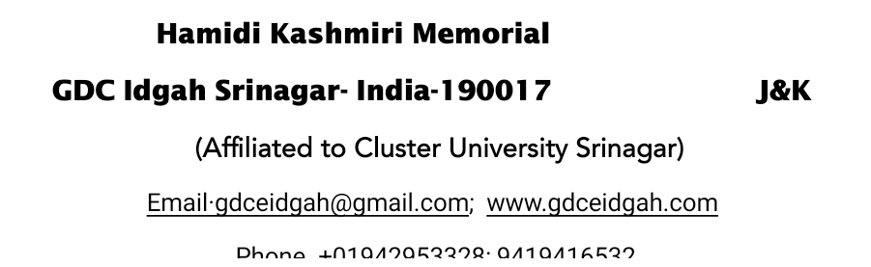



No: HKM/GDC/ED/One day Seminar
Dated: 12-4-2025
Report on One day Seminar on “The Life history of Dr B.R Ambedkar” organized at HKM GDC Eidgah
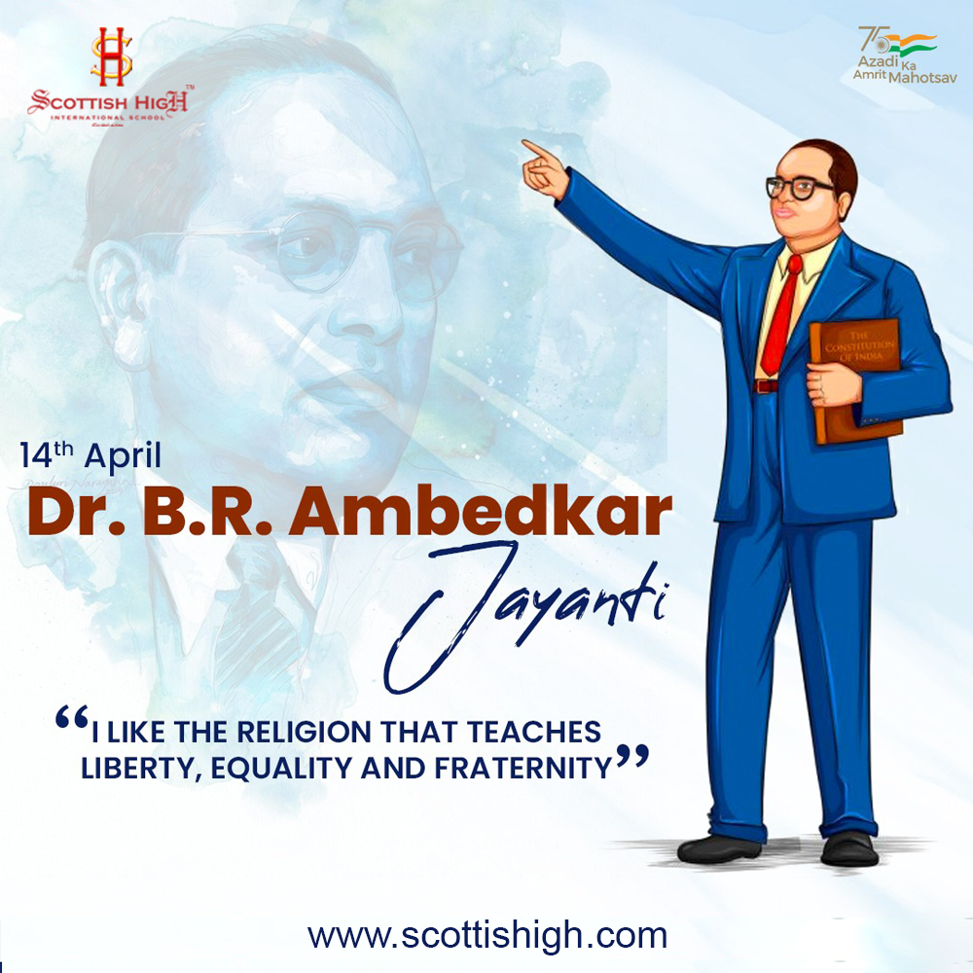
In Commemoration of the Birth Anniversary of Dr B.R Ambedkar, NSS Wings of HKM GDC Eidgah in collaboration with Department of Political science organized a one day Seminar on “Life History of Dr B.R Ambedkar on 12-04-2025 at 12.00 noon. The event aimed to highlight the immense contributions of Dr Ambedkar as a social reformer, economist, and the principal architect of the Indian
The programme commenced with an Inaugural address by Dr Nusrat Shafi (Associate Professor Chemistry) who highlighted Dr Ambedkar’s pivotal role in shaping the democratic principles of India. The inaugural address was followed by an informative lecture by Dr Zakir Hussain (Assistant Prof. Political science) who emphasized on the role of Dr B.R Ambedkar in framing the constitution of India. He also discussed his vision for an inclusive society, his role as the chairman of the drafting committee, and the constitutional safeguards he advocated for marginalized groups. Many students of the college also participated in the programme and talked about life, education, fight of Dr B.R Ambedkar against discrimination faced by Dalit Community. The program concluded with the vote of Thanks By Dr Shah Faisal Jan (NSS PO I).
In conclusion the one day seminar on the life of Dr B.R Ambedkar proved to be an enriching and enlightening experience. Students left with a renewed appreciation for his contributions to social justice, equality and Nation building.
