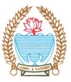
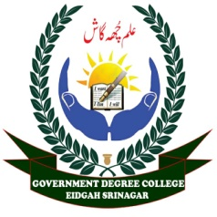
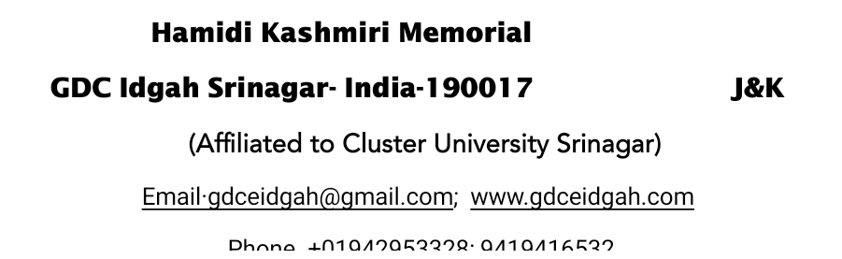



No: HKM/GDC/ED/Community outreach program
Dated: 25-o3-2025

Report on Outreach Program organized by HKM GDC Eidgah to Sensitize and Aware Local Community about Women’s Nutrition.
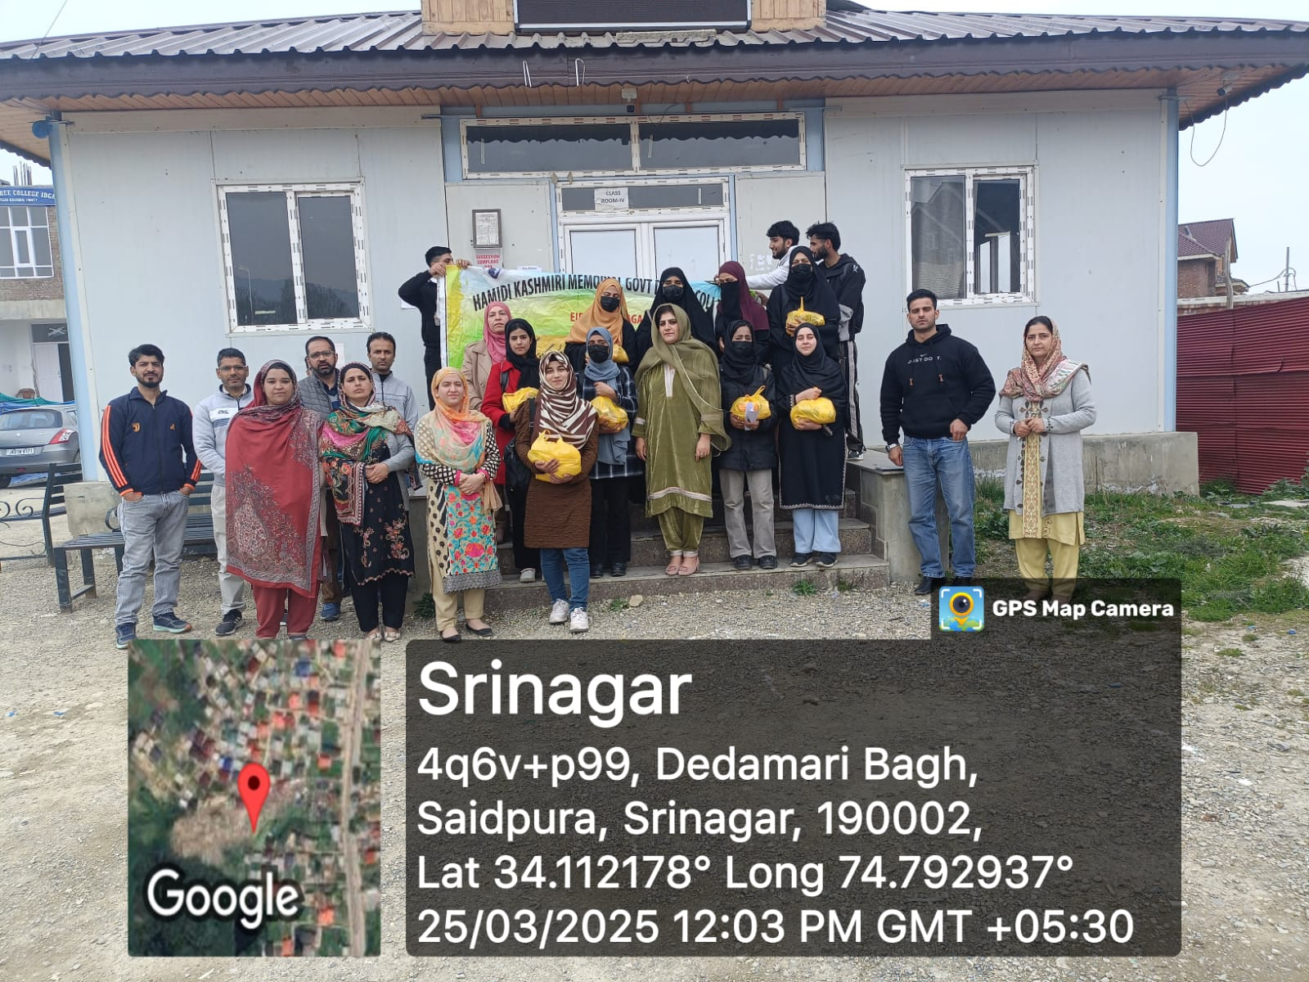
In an effort to promote awareness about the importance of women’s nutrition, The NSS Units in collaboration with Women Development Cell (WDC), Red Ribbon Club, GCCASH of HKM GDC Eidgah organized a Community outreach on Sensitization and awareness of the local community of Eidgah about Women’s nutrition under the banner of Beti Bachao, Beti Padhao on 25/03/2025. The program aimed to educate the women of the local community on the significance of balanced nutrition and to encourage them to adopt healthy dietary practices for better physical and mental wellbeing. The programme was conducted under the Patronage and able guidance of Worthy Principal of the college, Prof.(Dr) Nighat Nasreen.
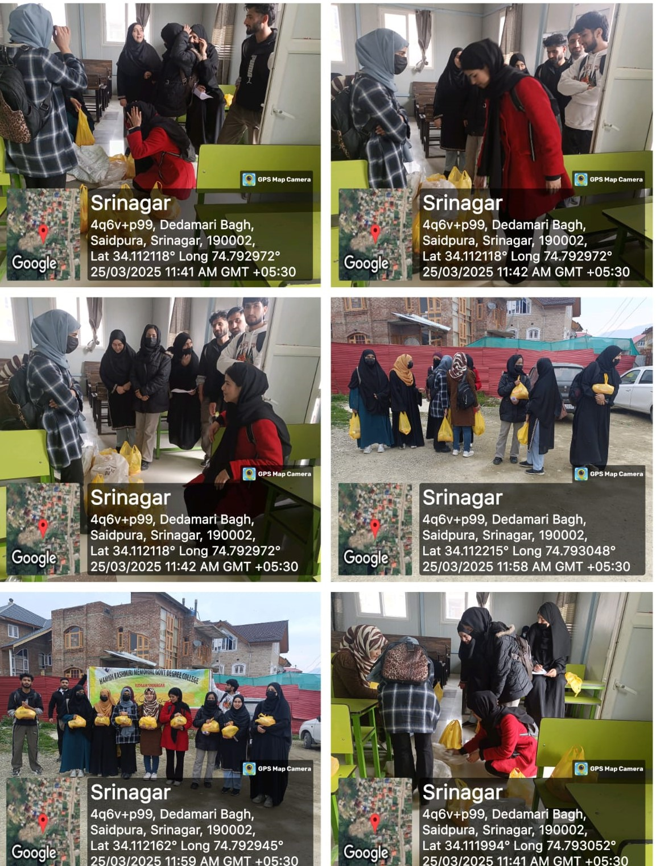
The preparation of program began two hours before, with the NSS Volunteers packing the nutritional items for distribution within the local community. After packing all the kits, the volunteers assembled in front of the college administrative block of the college. The event was inaugurated by Worthy Principal Madam who emphasized the crucial role of nutrition in ensuring the overall health of women and their families. She highlighted that addressing nutritional gaps among women is essential for fostering healthier communities. She applauded the efforts of the NSS volunteers for taking the initiative to reach out to the local community. With these words, the volunteers under the supervision of Dr Shah Faisal Jan (NSS PO Unit I), Dr Jabeena Khazir (NSS PO Unit II), Dr Nusrat Shafi (Co-ordinator RRC), Prof. Sabia Zahra (Convener WDC) and other faculty members, marched towards the local community of Eidgah to carry out the Door to door campaign and engage directly with the women and their families. The volunteers educated the women about the importance of consuming a balanced diet rich in essential nutrients. As part of this initiative nutritional kits were distributed to women of every house hold. Each kit contained nutritional items such as Pulses (2Kg), sugar (1 Kg), mustard oil (1L) and Soji (500gm). The distribution aimed to provide immediate nutritional support and encourage sustainable dietary practices. The local women expressed their gratitude and shared their insights on the impact of the information and materials provided. The programme concluded with the vote of thanks by Dr Nusrat Shafi (Coordinator RRC ). In conclusion the outreach program has a significant impact by enhancing awareness among local women about the importance of nutrition. Refreshment was provided to all the participants.

