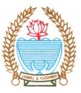
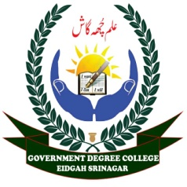
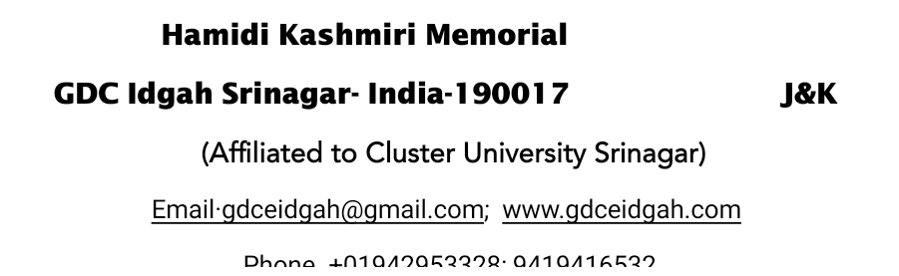



No: HKM/GDC/ED/Poshan Pledge
Dated: 16-4-2025
Report on Poshan Pledge organized at HKM GDC Eidgah
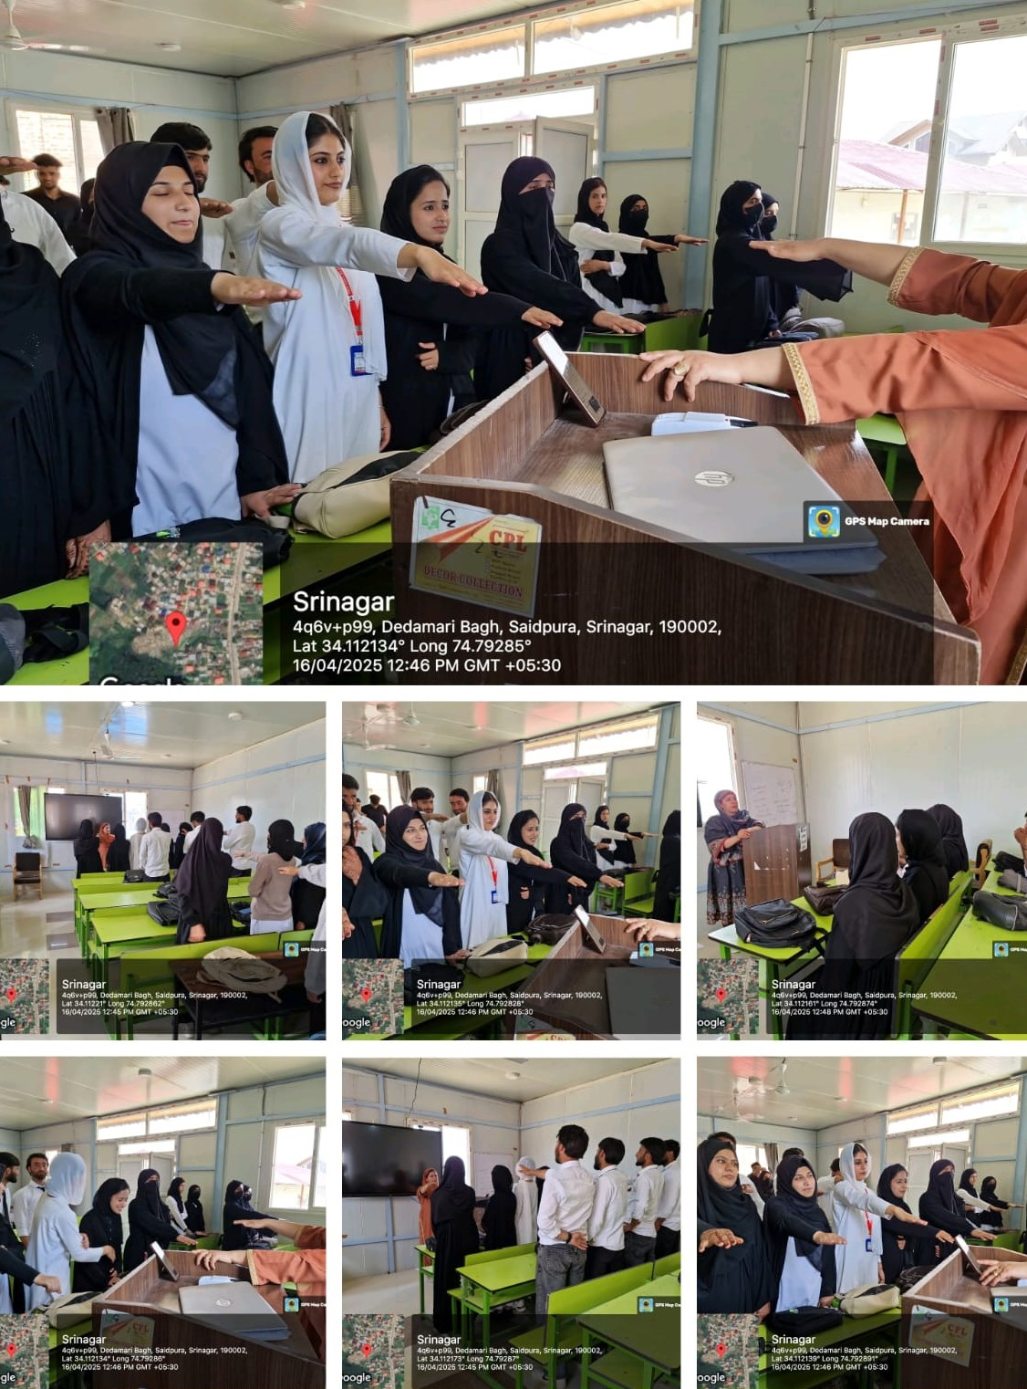
As Part of the Nationwide 7th Poshan Abhiyaan Pakhwada (Poshan Abhiyan Mission 2.0), NSS Units of HKM GDC Eidgah organized a Poshan Pledge event on 16/04/2025. The event aimed to raise awareness about the importance of nutrition and to encourage students and staff to adopt healthy dietary practices in their daily lives.
The program began with a brief introduction to the objectives of the Poshan Abhiyaan by Dr Nusrat Shafi (Associate Professor Chemistry), highlighting the need for collective action in eradicating malnutrition from our society. Following this, Dr Jabeena Khazir (NSS PO) read the Poshan Pledge to all present, where participants solemnly vowed to spread awareness about nutrition, consume balanced diets, and encourage others to do the same. Students and faculty members participated in the event enthusiastically. The atmosphere was filled with a sense of responsibility and commitment towards building a healthier and more nourished nation. The program concluded with the vote of thanks by Dr Shah Faisal Jan

