 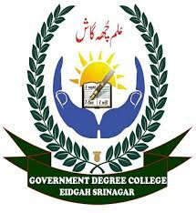

**CLUSTER UNIVERSITY SRINAGAR**

**HKM GDC EIDGAH SRINAGAR**

**Facilitation Centre for Admission -2023**

For any query related to admission through common admission portal

**https:/jkadmission.samarth.ac.in**.

**Contact** - Prof. Rehana Rasool (Convener, College Admission Committee)

**(Mobile no.: 9797064113, Email:** [**rehanrasool75@gmail.com**](mailto:rehanrasool75@gmail.com)**)**

**Principal**

**HKM GDC Eidgah**